LAB_3 7 segment display interfacing with PIC controller

1. Objective:
- To be familiar with PIC Microcontroller
- To be familiar with PIC16F877A Microcontroller internal and external structure and its configuration.
- To know how a the 7 seg display interfacing with pic microcontroller .
2. Required Components
Table 1. Components
Qty. | Component Name
1 | PIC18F4550
1 | BreadBoard
1 | 7 seg display
5 | Push Buttons
1 | Resistors Kit
1 | Capacitors Kit
1 | Jumper Wires Pack
1 | LM7805 Voltage Regulator (5v)
1 | Crystal Oscillator
1 | PICkit2 or 3 Programmer
1 | 9v Battery or DC Power Supply

3. Introduction
3.1 How does a 7 segment display work?
A seven segment display module is an electronic device used to display digital numbers and it is made up of seven led segments. LEDs are PN-junction diodes which emit energy by a process called electroluminescence. The light energy is emitted as when it is forward biased by a voltage applied across its junctions. In a seven segment display module, seven LEDs are arranged in a rectangle. Sometimes, an additional LED is seen in a seven segment display unit which is meant for displaying a decimal point.
Each LED segment has one of its pins brought out of the rectangular package. Other pins are connected together to a common terminal.
Seven segment displays can only display 0 to 9 numbers. These seven LEDs indicate seven segments of the numbers and a dot point. Out of many types of segment displays available, this is the most common form.
It was mentioned earlier that the LEDs emit light only when it is forward biased and the amount of light emitted is proportional to the forward current. Since the light emission is directly proportional to the forward current, it is necessary to control the forward current according to the requirement of light emission. To limit forward current, a series resistance is connected to the voltage supply. To overcome the forward voltage drop, the voltage supplied should be greater than the actual forward voltage value.
Seven segment displays are seen associated with a great number of devices such as clocks, digital home appliances, signal boards on roads etc.
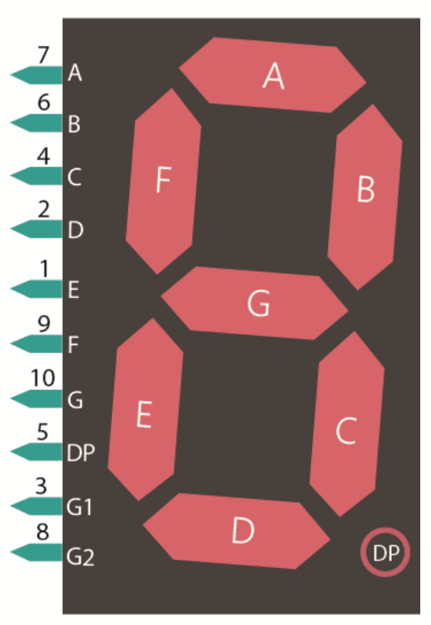
3.2. Types of seven segment displays
The seven segment displays have two different configurations. They are the common anode and a common cathode. One pin each from each segment is connected to a common terminal. According to the pins which are connected to the common terminal, the seven segment display is categorized as a common anode and common cathode.
Common Anode 7-segment display
In this type, the anode is common. It should be connected to a high voltage (to the supply through a resistor to limit current). In order to turn on a particular segment, a ground level voltage is given to the corresponding pin. Since logic circuits can sink more current than they can source, common anode connection is used most widely.
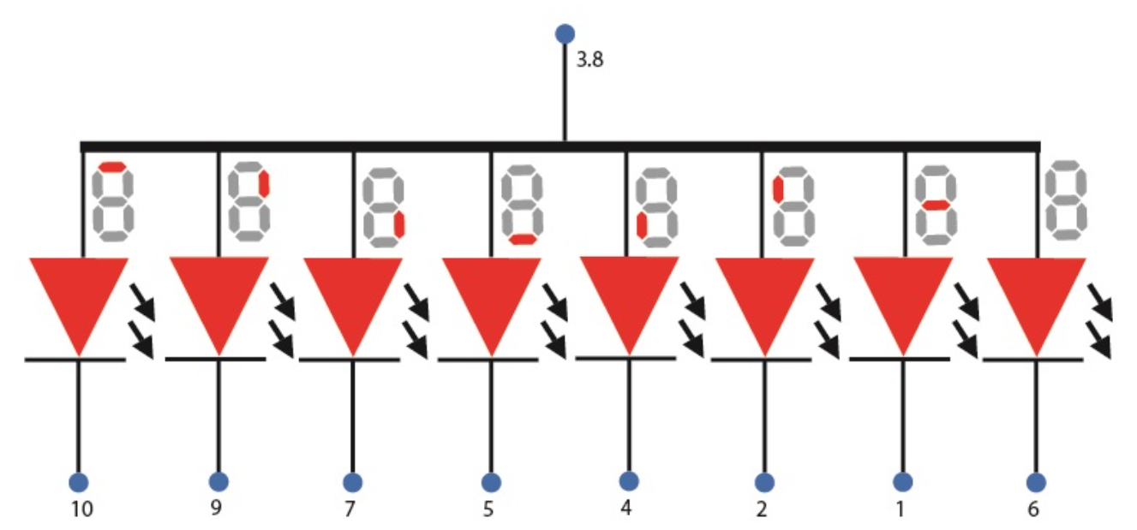
Common cathode - 7-segment display
Common Cathode 7-segment display
As the name indicates, its cathode is connected to a common terminal. Below is the schematic diagram to indicate its common cathode structure. It should be connected to the ground while operating the display. If a high voltage is given to the anode, then it will turn on the corresponding segment.
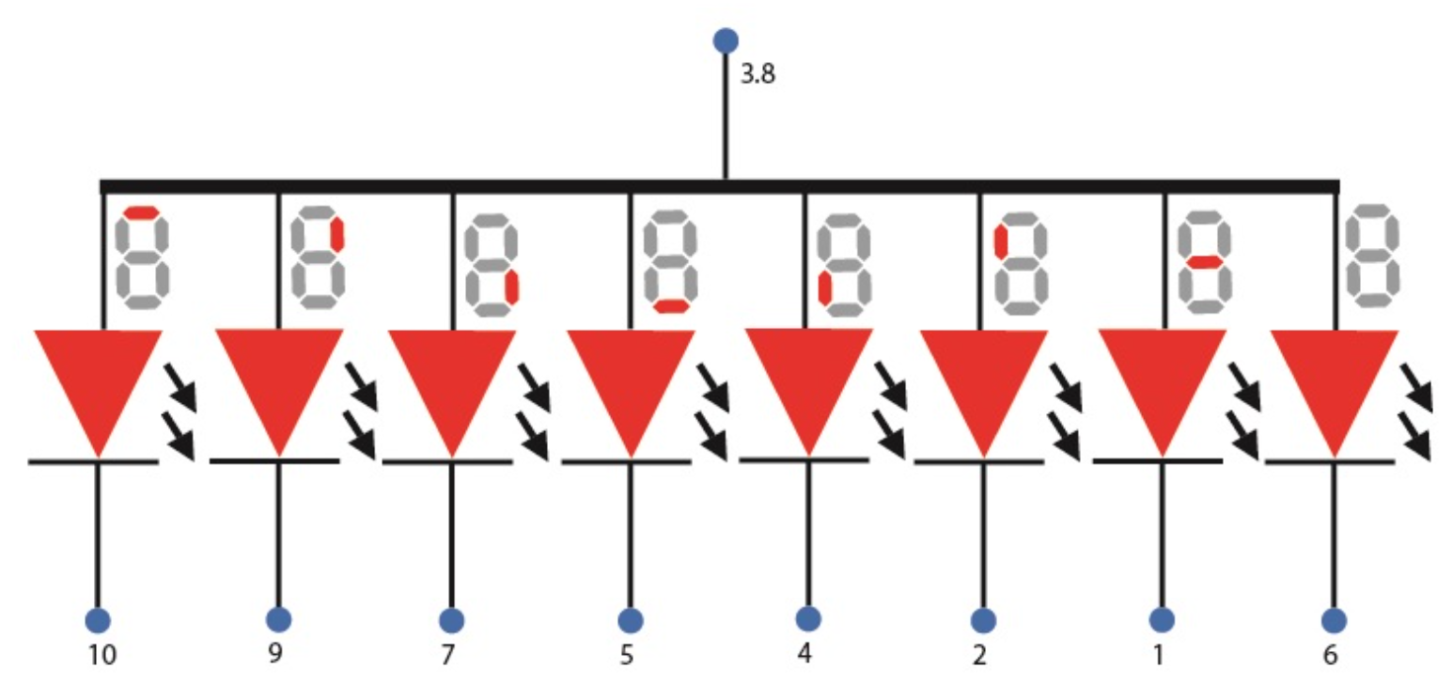

3.3 Display codes
Display codes are the voltages to be applied to the segments to display a number. It is in the order of segments ABCDEFG(DP), total 8 bits. For example, below is the common cathode display code of ‘0’ with decimal point OFF. 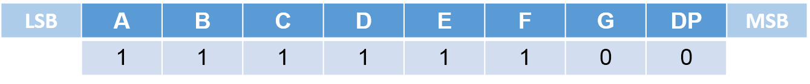
Below is a table with display codes of all the digits with decimal point OFF.
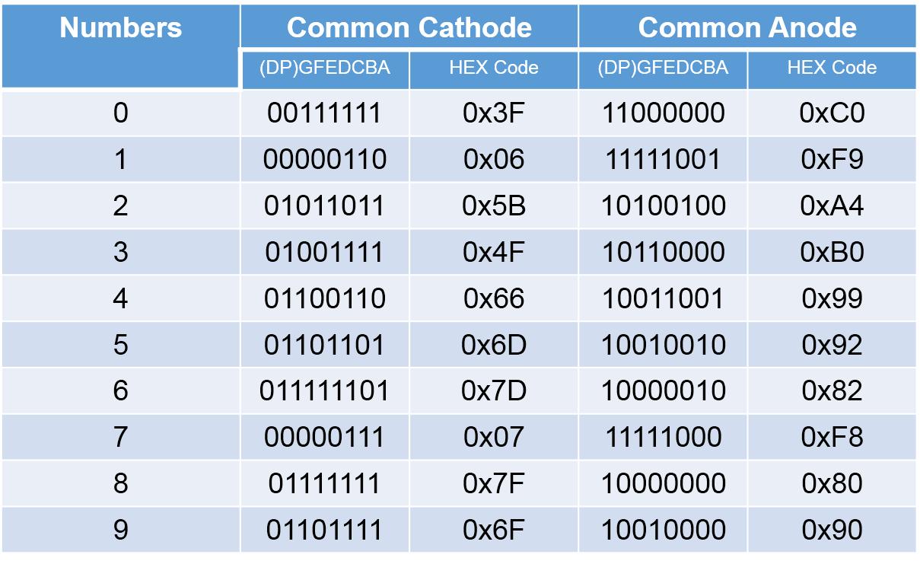
If number 0 has to be displayed, then the segments A through F are turned on. In order to turn on the segments, in common cathode mode, the anode terminals are subjected to a high voltage while in common anode mode, the cathode terminals are given a low voltage.
4. Experiment_ 7 segment display interfacing with PIC microcontroller
4.1 Coding:
- Open the MPLAB IDE and create a new project.
- Define the IO pins used for controlling (choosing) the desired speed levels and direction reversal.
- Output pins in order to send the direction control logic signal to the 7 segment display.
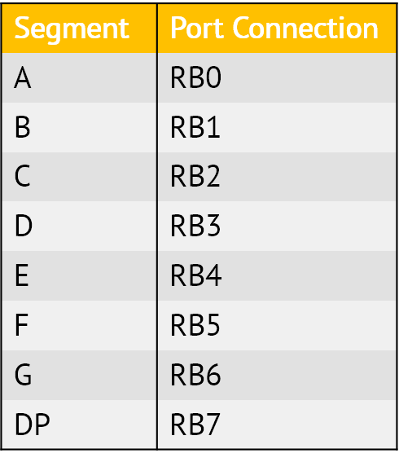
- Write the main loop (routine) of the system.

4.2 Simulation:
- Using Proteus with PIC18 and port B is connected to different segments. fetch hex file and run the simulation.

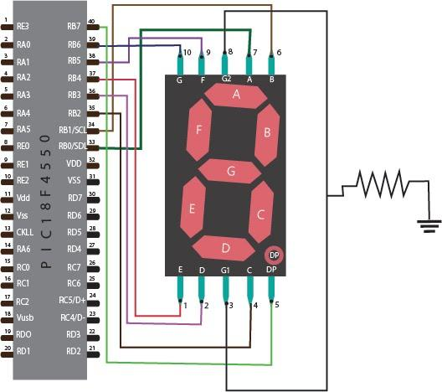

Figure . Circuit diagram
5. Homework
Write an C program for controlling the 7 segment display count up and count down.
Name: Student Code: Class: Lab:
- Circuit
- Algorithm flowchart
- Code and explanation
- Summary

